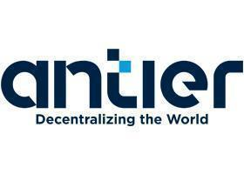

Chroncept FNFT Marketplace

Business Requirement Document

Date: 16.09.2022

# Table of Content

1. Version History
2. Overview of Project
3. Module list and Description of Modules
4. Stakeholders and governance
   1. Key Stakeholders
   2. Governance
5. Testing Reports
   1. Acceptance criteria
   2. Defect matrix
   3. Test Report

# Version History

|  |  |  |  |  |
| --- | --- | --- | --- | --- |
| **Version no** | **Date** | **Prepared by/**  **Changed by** | **Reviewed by** | **Nature of amendment** |
| **1** | **07.09.2022** | **Nikhil Uppal** | **Prashant Hooda** | **Initial Requirement document** |
| **2** | **20.09.2022** | **Nikhil Uppal** | **Prashant Hooda** | **Change of Scope – ERC 20 and Exchange mechanism** |

# Overview of Project

Client wants to develop a Decentralized Phygital Fractional NFT Marketplace platform for Luxury Watches. Users would come, explore and buy watch NFT’s available from primary and secondary marketplaces.

* NFT’s and its fractions would be built with ERC721 and ERC20 tokens, which will be called shares or fractions.
* 2 types of participants – The Admin and the user
* The platform would be built on ETH blockchain
* Users can redeem the NFT and get the physical delivery of the Watch at their address.

# Module List

|  |  |
| --- | --- |
| **User Section** | |
| **Modules** | **Description** |
| **Onboarding** | Users will be able to connect to the platform with Web3auth and would have following options:   * Email * Social Login * External wallets   Users will directly land on the home page |
| **Wallet** | As soon as the user registers, a wallet address would be created and would be used for all transactions on the platform  As there are different ways to enter the platform within the web3auth, every way would have a different wallet address.  **Torus wallet** would be used to operate transactions and Store crypto and NFT’s.  Torus wallet is owned by web3auth and gives flexibility. |
| **Home Page** | As the theme template is given by the client itself, so it would show the following information:  Top menu:   * Logo * Search * Help center * Theme switch – Light and dark * Connect Wallet option   On page – Main content:   * Banner with Explore option * Top featured NFT’s * Top featured Collections   Footer:   * Logo * Small description about the platform * Social media links * Marketplace   + Collections   + NFT’s * **Platform name: Client dependency**   + **About**   + **Support**   + **Privacy policy**   + **Terms of service** * My account   + Profile   + Favorites * Contact us   **The above given specifications are standard NFT marketplace Home page features. Would change/modify according to the theme template provided by the client.** |
| **Profile** | Once the user logs in, they can access their profile from the top menu. they would find the below in his profile:   * Cover picture (Editable) * Profile picture (editable) * Name (Editable) * Edit option * My Items (Bought)   + Collections     - NFT’s and its shares * Favorites * Claim * Search functionality * Filters and Sort * Share profile link functionality |
| **Explore Marketplace** | User would be able to view all the luxury collections and NFT’s that are listed for sale on this page with different sort and filter options.  Grid would have the following detail:  If its Collection:   * Image * Collection name * No. of NFT’s in the collection * View option   If its NFT:   * Image * NFT name * Collection name * Favourite option * Shares available * Price * Buy option   A Toggle option would be given at the top to switch between   * exploring collections and the NFT’s. * Primary and secondary   Same toggle option would also be given for the Universal search bar. |
| **Collection detail page** | User would be able to view a detailed page on a particular collection where collection specific details and NFT’s under the collection would be visible. |
| **Buy NFT shares – Primary Marketplace**   * **Funding Stage** | When the user clicks on Buy, NFT detail page would open, which shows:   * NFT Preview * NFT Name * Collection Name * Description * About   + Price   + Shares Supply available   + Total Shares Supply   + Valuation   + Expiry time * Activity * Price Dynamics * Top Vault owners * Share NFT functionality   When the user again clicks on Buy,   * A pop would open to confirm the shares he wants to buy. * There would also be a check before proceeding, whether you have funds in your wallet or not. * If not, please add funds and you would be given the option to copy your address from the screen. * If yes, a transaction would take place.   Post this, **ownership** of those particular no. of shares bought would be transferred to the Buyer’s wallet address.  **Please note that:**   * **Only option is Fixed Buy for the primary marketplace.** * **Auction will be used for NFT Buyout.** * **Users can import NFT to any of his outside wallets. As soon as he does, the collection would also disappear.** * **Bringing other platform NFT won’t be possible on Chroncept platform** |
| **Currency used** | Only Crypto is acceptable - USDT  **Multi currencies?**  **3 currencies - USDT, USDC, ETH**  **Only possible for the Primary - Funding section.**  **In secondary, base currency would be the same.**  We can also show ETH converted price for the same amount of USDT via API.  User would also be available to purchase crypto via fiat using on ramp solutions.  **Client dependency: 3rd party On-ramp API required:**  **Transak, SendWyre, Moonpay and Simplex.** |
| **Tax** | Every time a transaction occurs w.r.t ERC20 tokens, there would be a certain %age tax on it.  %age – **2.5%**  This would be only in Secondary marketplace  Split tax into multiple wallets also available.  This tax would be sent to the admin's tax wallet address via smart contract automatically.  There would be a tax on ERC721 also. Which would work as royalty. |
| **Platform Fee** | 1% charge |
| **Resell further**  **Secondary Marketplace-**  **Trading Stage** | Users can buy and sell the fractions in the secondary marketplace:  Both these processes would work with an Exchange order book mechanism.  For a buy order to get executed, there has to be a sell order and vice versa.  An order book has 2 side:   * Green Side – Buy orders * Red Side – Sell orders   **Dynamic pricing** – Price would fluctuate depending on the average price of the orders.  Buy:   * No. of fractions * Price * Expires in time * USDT (no. of fraction x Price.)     Sell:   * No. of fractions * Price * Expires in time * USDT (no. of fraction x Price.)   Every time you place an order, there would be a transaction on blockchain and gas fees would be deducted.  **Explained in detail at last.** |
| **Buyout - Auction** | If a user wants to buy the entire 100% fractions or the entire NFT, that is possible when the user initiates an auction.   * Initiates auction by entering price and expiry time. * Initiator’s Funds would be locked for a day in an escrow account – basically to provide liquidity. * For the auction to be successful, at least 51% of the votes have to be positive i.e accept the auction offered price. * If no, time period expires, the auction will be canceled. * If yes, the initiator will get ERC 721 minted to his wallet. * Now, the buyer will have only 2 options:   + Either Redeem   + Or Withdraw * Buyer will have to pay a royalty tax during the whole buyout as well. %age **- 2.5%**   Users who hold the other 49% will be able to claim their share of the amount from the smart contract manually.  A subtab called “Claim” can be given on the profile page. |
| **Redeem** | Users can only redeem a watch NFT when they have done a Buyout auction and got ERC721 NFT minted in their wallet.  Redeem means they will get the physical watch delivered to them in the real world.  **Pre – requisite: KYC**  If a user wants to redeem, KYC is mandatory and it would require Admin’s approval.  Flow would be:   * User goes to my profile and chooses the specific NFT. * User clicks on Redeem.   + It would run a background check whether KYC is done or not.     - If not, it would take you to the KYC page to complete it.     - If yes, would proceed with the redemption process.   This would be manual KYC and would ask for following details: (**Details can be furnished from client)**   * Full Name * Email address (auto fetched-disable) * Phone number * Live Photo (TBC) * Address * Postal code * Upload Doc type:   + Front and back   + **Client dependency** * City and country   Once he enters and submits everything, the request would go to the admin.  It would be in admin hands whether to approve the KYC or reject it. |
| **Shipment track** | Shipment to be taken care outside the platform by the client itself and the details to be shared to the users via Mail/Text.  Users will be able to track the shipment of the Watch on the 3rd party’s website.  **Shipment charges can be taken at the time of redemption based on the location at which they are getting the Watch shipped** |
| **Mails** | 1. Welcome Email  2. KYC submission  3. KYC Approval/Reject  4. Redeem request Approval/Reject  5. NFT buy  6. NFT sell |

|  |  |
| --- | --- |
| **Admin** | |
| **Modules** | **Description** |
| **Onboarding** | Admin can login via Central wallet and there would be a central wallet associated with it. |
| **Landing page - Dashboard** | Dashboard would contain the basic dynamic tabs:   * No. of users on the platform * No. of collections * No. of NFT’s * KYC requests |
| **Users List** | Admin would be able to see the list of all the users on the platform with the following details:   * Profile picture * Name * Wallet address * Email * No. of NFT holdings * Created date and time   There would also be a Search bar and Filters on this page. |
| **Collections and NFT’s Management** | Admin would be able to see a list of all collections and NFT’s listed on the platform:  If its collection:   * Logo Picture * Collection Name * NFT it holds   If its NFT:   * Picture * NFT Name * Owner * Total No. of shares * No. of shares available * Current Price |
| **Create Collection** | Every NFT belongs to a particular collection.  Admin can create a collection and enter the following details:   * Collection name * URL * Description * 2 types of images   + Featured   + Cover   Collection would be added to the My items and can be empty until any NFT is added under it.  Collection to be created at the DB level - Off chain. |
| **Create NFT** | After the collection is created, admin will create the NFT with the following data:   * File upload – MP4,JPG,PNG,SVG,GIF * Name * Description * No. of shares/fractions * Transfer tax per share * Price * Collection - Part of the existing collection??   + If yes - choose the collection.   + If no - Create collection first Pop - up and nothing would be saved.   Once NFT is created, it would be added to the collection mentioned. |
| **Vault Creation** | As the NFT gets created, a smart contract Vault would be created which will do the following functions:   * Lock ERC 721 NFT just created * Create ERC tokens for the same NFT, quantity depends on the fractions mentioned while creating NFT. * Minimum quantity of tokens can be kept at 100.   This NFT will get listed on the User end. |
| **KYC requests** | Admin will see all the KYC requests here in this tab. He would see all the info the user uploaded while applying for KYC.   * User profile picture * Name * Wallet address * Mail id * Created date and time * No. of NFT’s he holds * KYC Info – would open a separate page where all info would be there – residence, id etc. * Accept / Reject   Under KYC, there would be 2-3 toggle sub-tabs :   * All requests * Accepted * Rejected   **Once a user’s KYC is rejected. Can he apply again? Question**  The user can apply again for the KYC. |
| **Logistics management** | Admin will view all the requests taken up for redemption here:   * View all requests * Accept/Decline Requests * Mark status as shipped * View Delivered orders   Shipment would be taken care of by the client itself off the platform and the details would be shared to the users via Mail/Text.  Users and admin would be able to track the shipment of the Watch on the courier service website. |
| **Tax** | Tax will be collected every time ERC20 tokens get traded on the platform.  **Tax %age is dynamic in nature and can be changed by the admin.**  **Client Dependency: %age**  **Primary - No tax**  **Secondary - Exchange - 2.5%**  **Admin can change it from the panel** |
| **Platform fee management** | 1% charge |
| **Reports** | Admin would be able to see and **download** the following reports:   * Buy * Revenue * Minting |

# Important Requirements:

|  |  |
| --- | --- |
| **Particular** | **Detail** |
| **SMTP**  **(To send mails)** |  |
| **Logo** |  |
| **UI Theme template** |  |
| **AWS details**  **(Code host)** |  |
| **Infura**  **(Transaction capture)** |  |
| **Twilio**  **(Text services)** |  |
| **On ramp solution**  **(Fiat to crypto)** |  |

# Flow diagram:

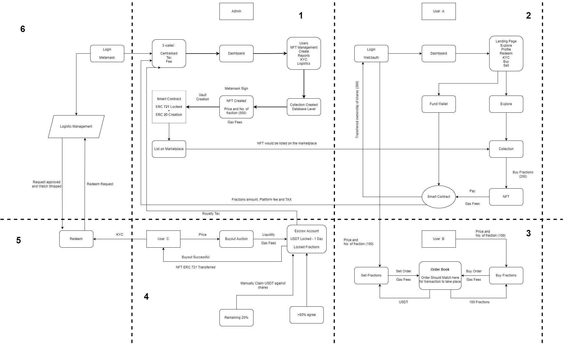

# Working of a Trading book in Exchange:

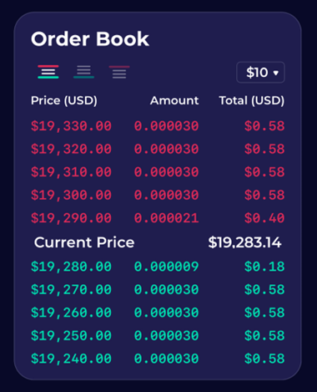

|  |  |
| --- | --- |
| Buy | Sell |
| Scenario 1 - User A places a buy order of 0.000030 Shares @ 19,305 USD   * Order execution -   + 0.000021 @ $19,290   + 0.000009 @ $19,300 * Reason - Trades available where price <= 19,305 USD | Scenario 2 - User D places a sell order of 0.000060 shares @ 19,265   * Order execution -   + 0.000009 @ $19,280   + 0.000030 @ $19,270   + Remaining 0.000021 would be listed on sell side * Reason - Partial Trades as shares not available where price >= $19,280 USD |

# Stakeholders and Governance

# 

# Testing

## Acceptance Criterion

The Product/sprint will be stand accepted only when it has passed following testing criterion

1. Tested by Dev team - Result Passed
2. Tested By QA - Result passed - with Test sheet and screenshot of testing attached

## Defect Matrix -Bug Report

The Defect Matrix Report should consist following information

1. Defect Information
2. Defect type - UI or functional  
   Defect subtype - Frontend or backend or smart contract
3. Defect resolution Date - Should include QA
4. Responsible Person
5. Comment section - Dev/QA/BA/PO

## Test Report

The Test report of the product should include following

1. Functionality Tested
2. Outcome Result
3. Expected Result
4. Deviation
5. Result - Passed or Failed.